Environment and Energy

1, 2, Tree promotional kit

Resources to promote 1, 2, Tree
- Use the sample newsletter article to share on your organization’s website or in your newsletters. These are editable so you can customize the length or message.
- Use the sample social media posts to share through your social media channels.
- Follow and reshare messages posted on the Hennepin County Environment and Energy social media channels: Hennepin Environment on Facebook, Hennepin Environment on Instagram, and @hennepinenviro on Twitter.
- Share the information and resources available at HennepinTrees.org.

Contact
For more information and trees and forestry contact trees@hennepin.us or Dustin Ellis at 612-348-2259
For communications inquiries or additional promotional material requests, contact Angie Ziobro: angie.ziobro@hennepin.us or 612-348-9850

Newsletter article

Help Hennepin County plant 1 million trees with 1, 2, Tree
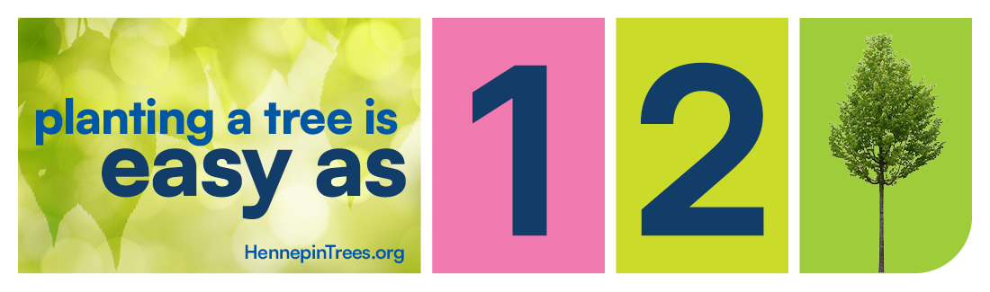
Every tree planted means prettier neighborhoods, cooler yards, and healthier communities. Hennepin County is over halfway to its climate-action goal of planting 1 million trees by 2030. Every tree gets us closer, and the best part is, you can help make it happen! It’s easy as 1, 2, Tree.
- Pick the right tree for you
- Plant the tree
- Take care of the tree
Find a tree selection quiz, helpful videos, and links to resources at HennepinTrees.org. It’s that easy!

Social media post
Note: Remove the link from the post caption in Instagram and replace with “Link in bio” and in in your bio.
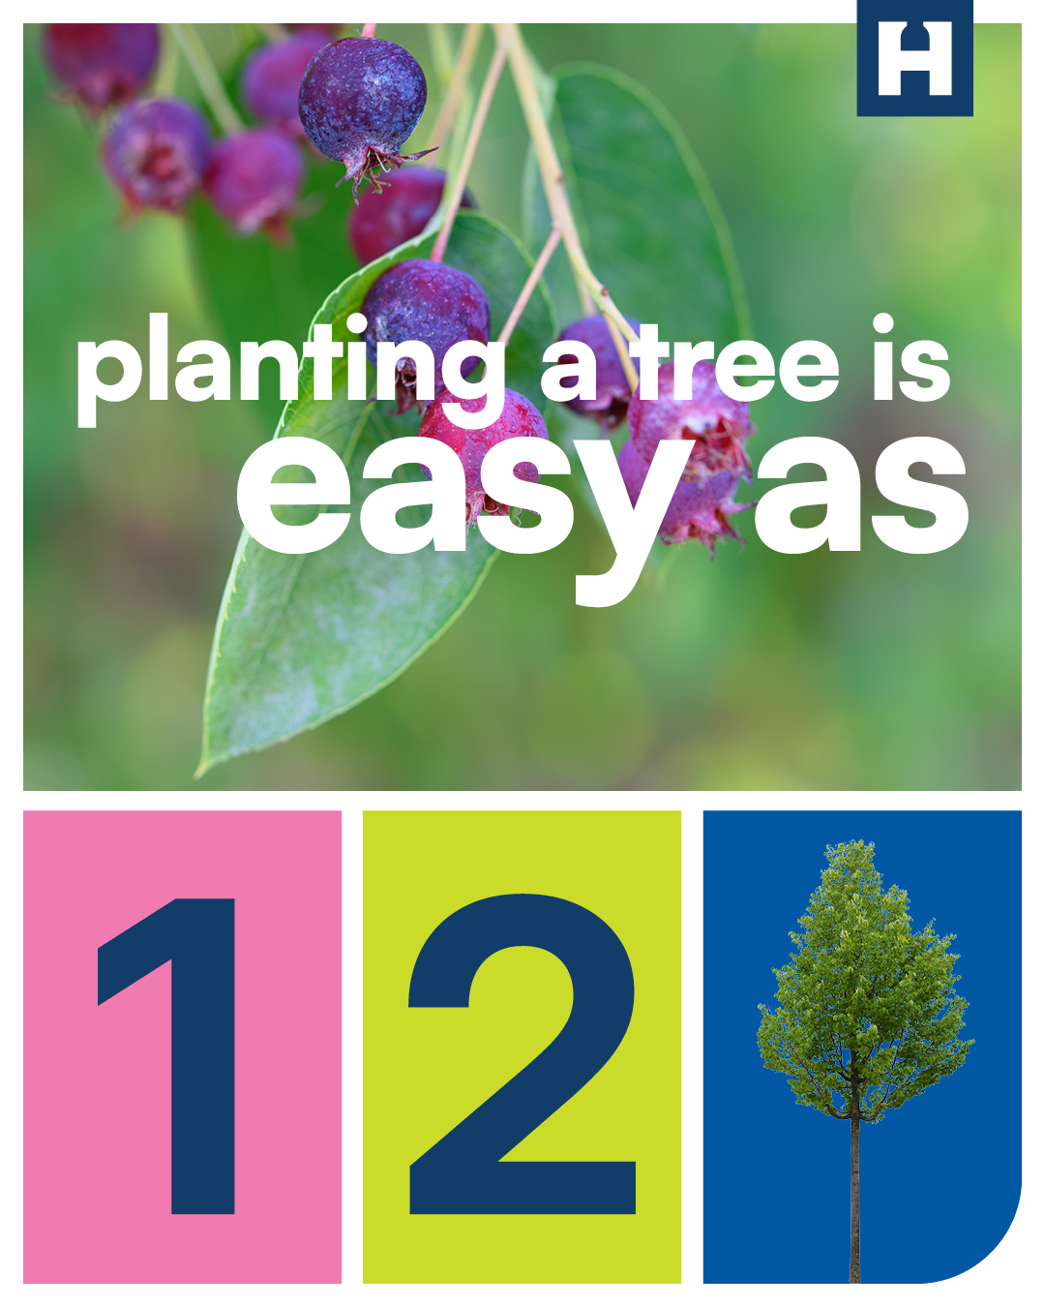
Planting a tree is easy as 1, 2, Tree. Pick the right tree, plant it, and take care of it. Hennepin County has videos and resources to help make each step easier at HennepinTrees.org.

Social media story
Note: Add a link to HennepinTrees.org as a button on the story.
