Environment and Energy

Salvage Crawl
  - Content kit 06/22/2026

About Hennepin County’s Salvage Crawl
This July, Hennepin County is hosting a Salvage Crawl, where people are enticed to buy used—rather than new—building materials for home remodeling projects.

How to participate
Residents visit participating salvage retailers from July 13-31, 2026, to be entered into a drawing to win prizes. Look for Hennepin County’s Salvage Crawl poster near the checkout counter at each retailer’s location and scan the QR code to enter your information for a chance to win prizes.

Resources to promote the Salvage Crawl
We need your help to make it a success. Share content from the Salvage Crawl Media Kit with your audiences! Ways to educate the public about the Salvage Crawl:
- Use the sample newsletter article and social media post to share on your organization’s website, newsletters, and social media channels. They are editable so you can customize the length or message.
- Follow and reshare messages posted on the Hennepin County Environment and Energy social media channels: Hennepin Environment on Facebook, Hennepin Environment on Instagram, and @hennepinenviro on X/Twitter.
- Share the information and resources available at HennepinCounty.gov/salvage-crawl
- Find an interactive map of participating retailers at HennepinCounty.gov/salvage-crawl

Contact
For more information about the Salvage Crawl, contact:
- Fernanda Acosta, Hennepin County construction and demolition specialist, fernanda.acosta@hennepin.us
- Christina Schmitt, Hennepin County Environment and Energy communications, christina.schmitt@hennepin.us

Newsletter article
Note: To use images: Right click on image and select save as picture.
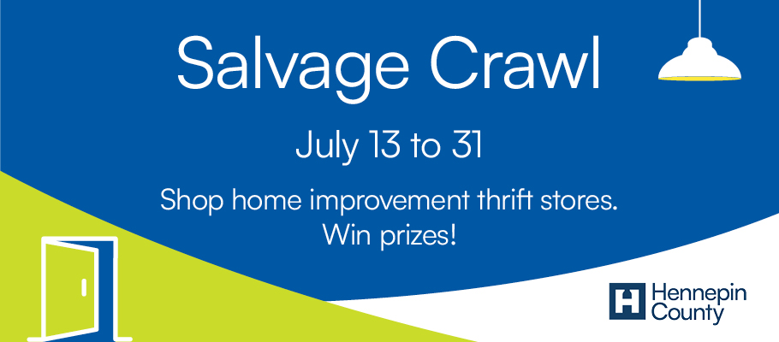

Salvage Crawl July 13 to 31
Join treasure hunters and DIY enthusiasts to shop at local salvage retailers—and win prizes! Participate in Hennepin County’s Salvage Crawl and get to know 13 home improvement thrift stores in the Twin Cities.
Find the list of retailers and interactive map at HennepinCounty.gov/salvage-crawl.
Salvage retailers offer a wide variety of building materials, hardware, tools, and other home improvement items. From old growth lumber to vintage light fixtures and everything in between, you’ll be sure to find both inspiration and quality materials for your next project.
How to participate
Visit participating salvage retailers from July 13 to 31 and check in using the QR code on the Hennepin County Salvage Crawl poster near the checkout counter. Once you hit submit, you will be entered into a drawing to win prizes. Find a list of retailers, interactive map, and description of prizes at HennepinCounty.gov/salvage-crawl.

Social media post
Note: To use images: Right click on image and select save as picture.
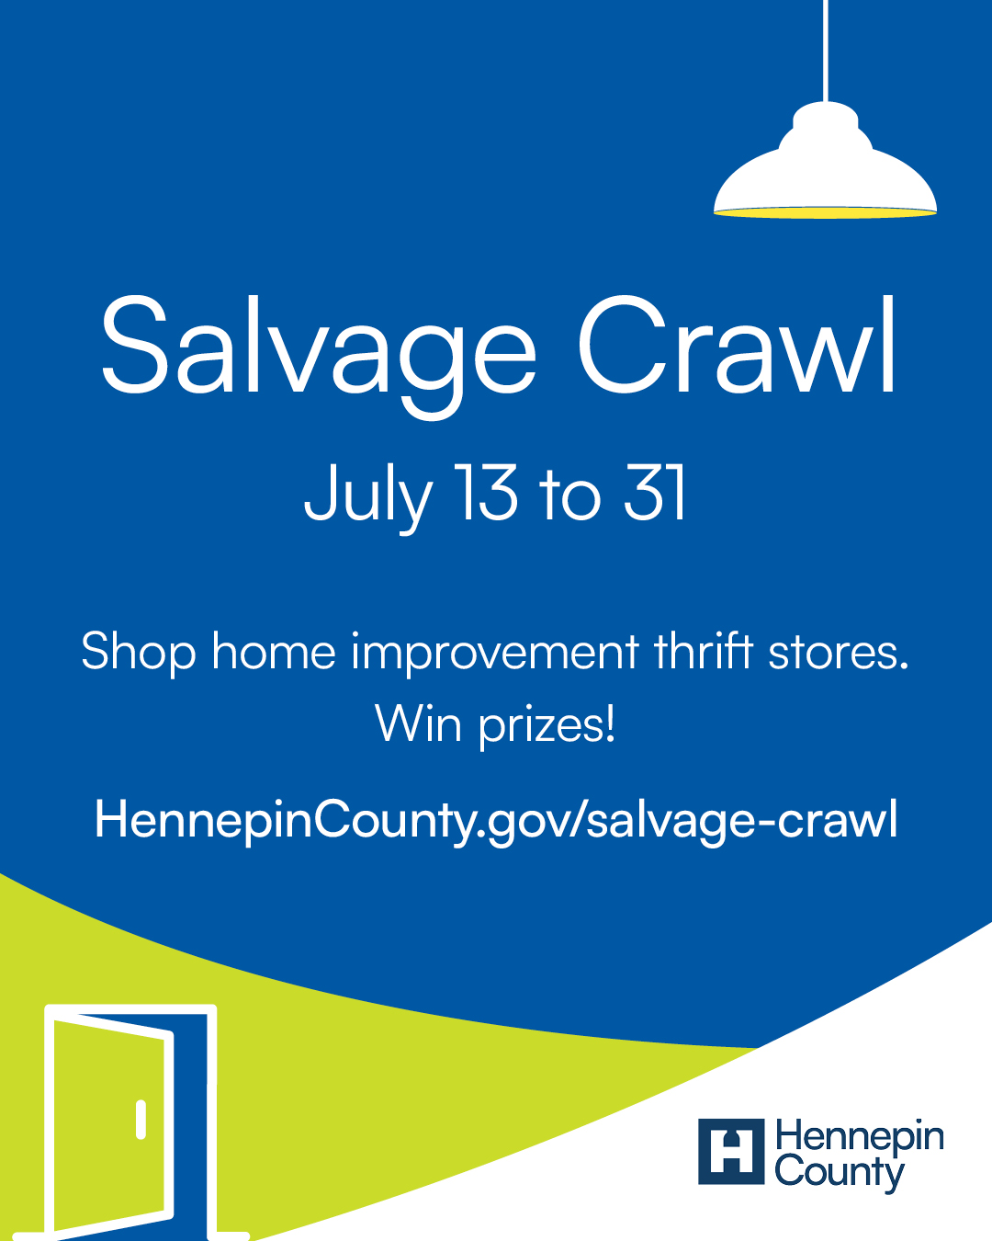
Caption: From July 13 to 31, join treasure hunters and DIY enthusiasts to shop at local salvage retailers and win prizes. Learn more: HennepinCounty.gov/salvage-crawl.

