Environment and Energy

Swap It: Kitchen gadgets
  - Promotional kit

About Hennepin County’s Swap-It events
Swap-It events are a fun sustainable way to reduce waste, share resources, build community and support local reuse efforts. The events are held in cities across Hennepin County and focus on a variety of materials, such as toys, household goods, building materials, and more. Reuse Minnesota runs the events on behalf of Hennepin County.

Resources to promote Swap-It events
We need your help to make the event a success. Here are ways to educate the public about upcoming Swap-It events:
- Use the sample newsletter article and social media post to share on your organization’s website, newsletters, and social media channels. They are editable so you can customize the length or message.
- Follow and reshare messages posted on the Hennepin County Environment and Energy social media channels: Hennepin Environment on Facebook, Hennepin Environment on Instagram, and @hennepinenviro on X/Twitter.
- Share the information and resources available at HennepinCounty.gov/swap-it.

Contact
For more information about Hennepin County’s Swap-It events, contact: Kirsten Wahlberg, kirsten.wahlberg@hennepin.us or 612-543-0430.

Newsletter article
Note: To use images: Right click on image and select save as picture.
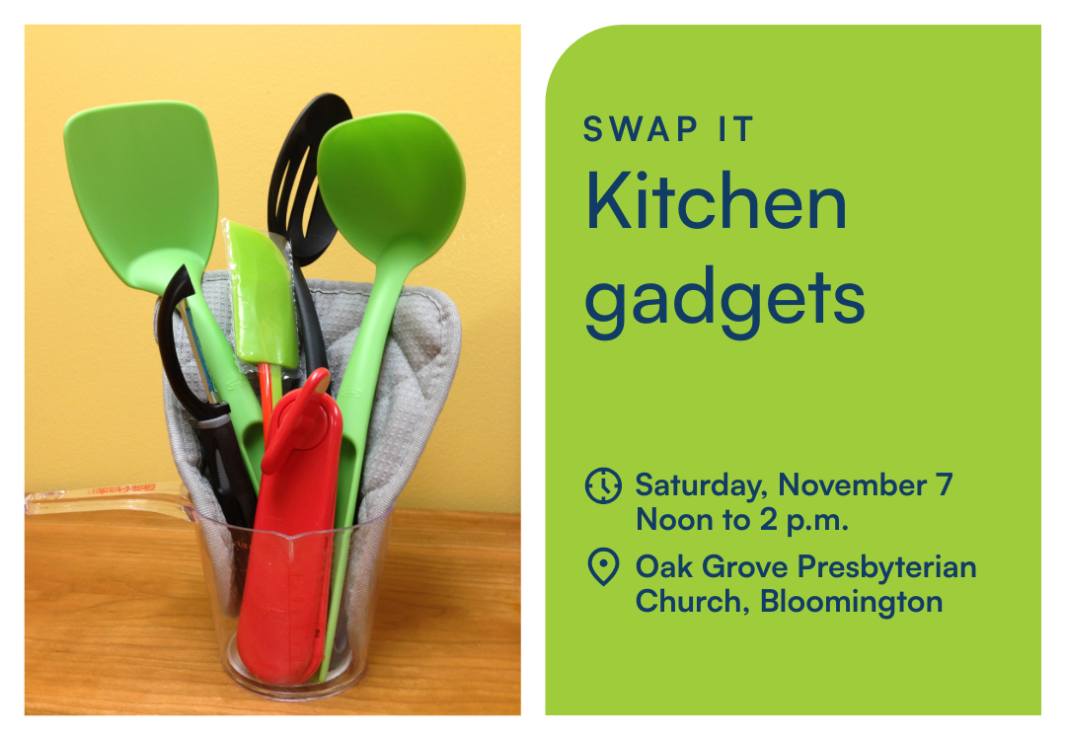

Swap It: Kitchen gadgets

Saturday, November 7 from noon to 2 p.m. at Oak Grove Presbyterian Church, 2200 W Old Shakopee Road, Bloomington
Bring gently used kitchen items you no longer need. Take home gadgets you can use. Swap it—for free! The theme for this Swap-It event is kitchen gadgets. From coffee makers to cutlery, blenders to bakeware: There’s something for every cook. Bon appétit!
Early drop-off available on Friday, November 6 from 1 to 3 p.m. (no swapping).
Find guidelines and a list of accepted items at HennepinCounty.gov/swap-it.
Questions? Contact Kirsten Wahlberg, kirsten.wahlberg@hennepin.us or 612-543-0430.

Alternate options for newsletter banner:


Social media post
Share the event on Facebook: https://www.facebook.com/share/1bMj2Wnnmc/
Follow and reshare messages posted on the Hennepin County Environment and Energy social media channels: Hennepin Environment on Facebook, Hennepin Environment on Instagram, and @hennepinenviro on X/Twitter.
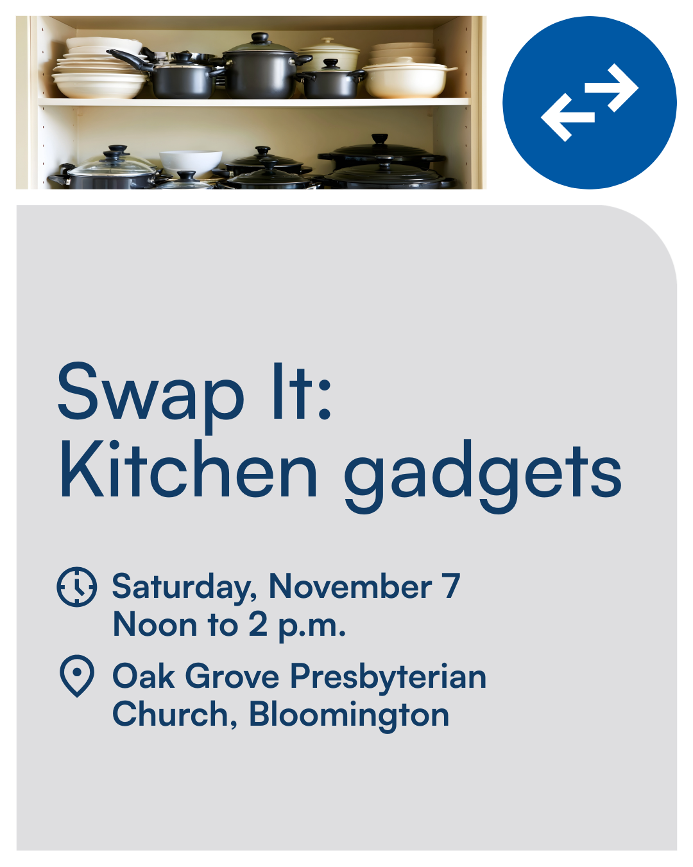

Social post:
Bring gently used kitchen items you no longer need. Take home gadgets you can use. Swap it—for free! The theme for this Swap-It event is kitchen gadgets. From coffee makers to cutlery, blenders to bakeware: There’s something for every cook. Bon appétit! https://www.HennepinCounty.gov/swap-it

