Environment and Energy

Swap It: Holiday decor
  - Promotional kit

About Hennepin County’s Swap-It events
Swap-It events are a fun sustainable way to reduce waste, share resources, build community and support local reuse efforts. The events are held in cities across Hennepin County and focus on a variety of materials, such as toys, household goods, building materials, and more. Reuse Minnesota runs the events on behalf of Hennepin County.

Resources to promote Swap-It events
We need your help to make the event a success. Here are ways to educate the public about upcoming Swap-It events:
- Use the sample newsletter article and social media post to share on your organization’s website, newsletters, and social media channels. They are editable so you can customize the length or message.
- Follow and reshare messages posted on the Hennepin County Environment and Energy social media channels: Hennepin Environment on Facebook, Hennepin Environment on Instagram, and @hennepinenviro on X/Twitter.
- Share the information and resources available at HennepinCounty.gov/swap-it.

Contact
For more information about Hennepin County’s Swap-It events, contact: Kirsten Wahlberg, kirsten.wahlberg@hennepin.us or 612-543-0430.

Newsletter article
Note: To use images: Right click on image and select save as picture.


Swap It: Holiday decor

Saturday, September 26 from noon to 2 p.m. at the Eden Prairie Community Center, 16700 Valley View Road, Eden Prairie
Bring gently used decorations you no longer need. Take home holiday decor you can use. Swap it—for free! The theme for this Swap-It event is holiday decor, from Halloween to New Year’s Eve and every holiday in between.
Early drop-off begins at 10 a.m. (no swapping). Final items accepted at 1:30 p.m.
Find guidelines and a list of accepted items at HennepinCounty.gov/swap-it.
Questions? Contact Kirsten Wahlberg, kirsten.wahlberg@hennepin.us or 612-543-0430.

Second option for newsletter banner:
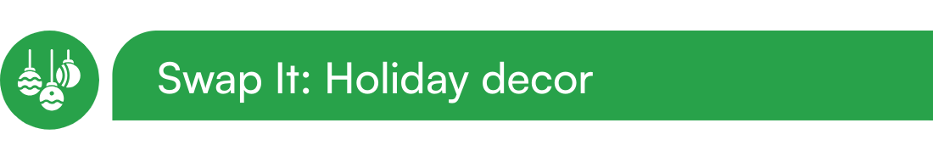

Social media post
Share the event on Facebook: https://www.facebook.com/share/1FfLxvYxNd/
Follow and reshare messages posted on the Hennepin County Environment and Energy social media channels: Hennepin Environment on Facebook, Hennepin Environment on Instagram, and @hennepinenviro on X/Twitter.
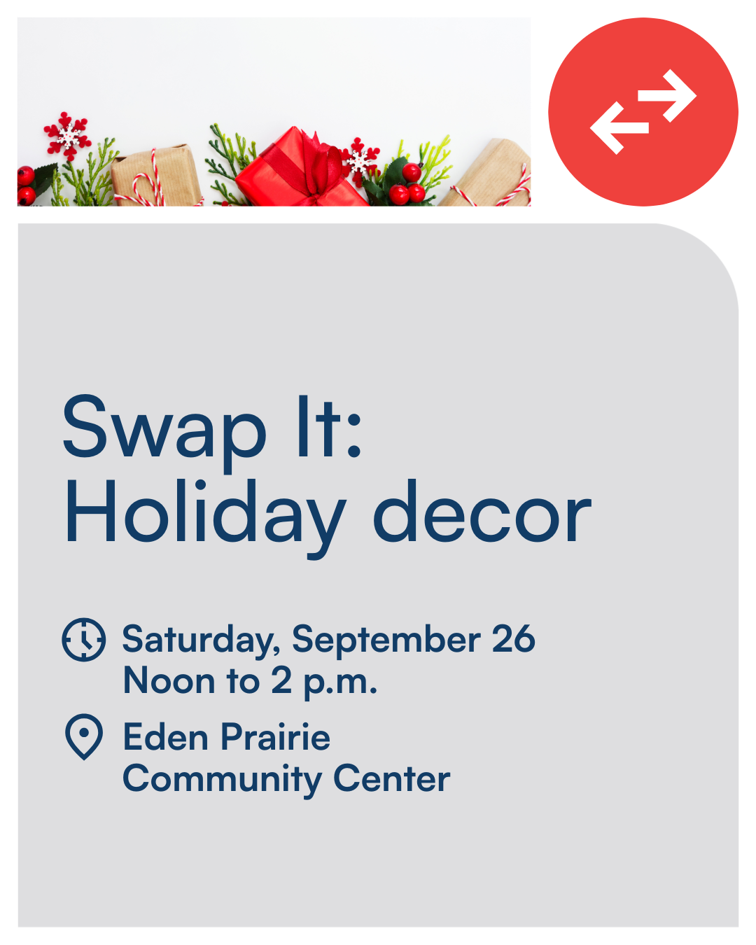

Social post:
Bring gently used decorations you no longer need. Take home holiday decor you can use. Swap it—for free! The theme for this Swap-It event is holiday decor, from Halloween to New Year’s Eve and every holiday in between. https://www.HennepinCounty.gov/swap-it

