

Actions to protect water quality media kit

About protecting water quality
No matter where you live, our choices are powerful because water moves. The raindrops that fall on our streets flow through storm drains that empty directly into our lakes, creeks, rivers, and wetlands. Raindrops pick up chemicals, pollutants, and debris that they touch along the way. Every point in a raindrop’s path is an opportunity to improve our water quality. Every positive choice and voice help improve our waterways, wildlife habitats and the beautiful, fun waters where we Minnesotans relax and play.

Resources to promote actions to protect water quality
Ways to educate the public about protecting water quality:
- Share the ten things you can do to protect water quality brochure. The brochure is available in English, Spanish, and Somali. Printed copies can be ordered from environmentalresources.hennepin.us/items
- Use the sample newsletter article to share on your organization’s website or in your newsletters. These are editable so you can customize the length or message.
- Use the sample social media posts to share through your social media channels. These are editable so you can customize the message and website.
- Follow and reshare messages posted on the Hennepin County Environment and Energy social media channels: Hennepin Environment on Facebook, Hennepin Environment on Instagram, and @hennepinenviro on Twitter.
- Share the information and resources available at hennepin.us/residents/conservation/protecting-natural-resources

Contact
For more information about protecting water quality, contact:
Emily McDonald, Environmental Educator, emily.mcdonald@hennepin.us

Sample newsletter article - long

Ten things you can to do protect our lakes and streams
Minnesota is home to thousands of lakes, rivers, and streams that are threatened by increasing development and pollution. While it may seem like protecting water quality in Minnesota is out of your control, there are many easy and inexpensive steps you can take to make a positive impact on water resources.
Get started by taking these ten actions:
- Salt sparingly. Shovel first, minimize salt use, sweep up excess. Just one teaspoon of salt permanently contaminates five gallons of fresh water. Shovel snow first, apply salt only to ice patches, use as little salt as possible, and sweep up leftover salt when ice is gone. Remember: More isn’t better, and sodium chloride, the most common deicer, stops working below 15°F.
- Keep streets clear of leaves and grass clippings. Sweep, rake, mulch or compost. Stormwater runoff carries leaves and grass clippings from streets into lakes and streams, where their nutrients cause destructive algae blooms. Use these nutrients to your benefit. Use them as mulch for weed suppression, or make them into compost to use as fertilizer. This protects water quality - and saves money!
- Kick the chemicals. Lawn and garden chemicals can harm pollinators and wash into the street’s storm drains that connect directly into nearby lakes and streams. Encourage the growth of healthy lawns and gardens. Pull weeds by hand or use spot treatment for weeds. If you have a weed or pest problem, consult the University of Minnesota Extension website for advice. Get a soil test before applying fertilizers. If you apply fertilizer, sweep up excess from pavement. Remember, a need for chemical treatments is an option of last resort.
- Mow high. Mow your grass to a height of three inches. Keeping your grass a little longer helps roots grow deeper into the soil, suppresses weeds, and requires less watering. If you do need to irrigate, do so in the morning and keep sprinklers on your lawn and plants, not on sidewalks or in the street.
- Scoop the poop. Pick up after pets. When pet waste is left behind, rain water washes it into lakes and streams. Pet waste contains bacteria, such as E. coli, that can cause illness in people, pets, and wildlife. Pet waste also contains nutrients that cause destructive algae blooms in lakes and streams.
- Adopt a storm drain. Keep drains free of leaves, grass clippings, and litter. Water entering a storm drain is carried directly to the nearest water body carrying leaves, grass, soil, litter and anything else it picks up along the way. This clogs stormwater infrastructure, contributes to street flooding, harms wildlife, and pollutes our waters. Remember, nothing but rain down the drain! Learn more and get resources at mn.adopt-a-drain.org
- Capture rainwater. Capture and clean rain water and recharge groundwater. Plant a rain garden, which collects rain water runoff, lets it soak into the ground, and filters out excess nutrients and other pollutants. Pollinators can benefit, too. You could also install a rain barrel, which captures rainwater from the roof of your house or garage to use in your garden. Or you can redirect downspouts to flow into your yard instead of running off into the street.
- Replace turf with native plants. Pledge to plant for pollinators and clean water. Trade some of your turf for native plants or choose a turfgrass alternative, which require less mowing and watering. Native plants provide pollinator habitat, are drought resistant, and their deep roots bring rain down into our ground water. Less mowing also improves air quality. Check local ordinances for maintenance requirements.
- Un-pave the way. Choose pervious paving for walks, patios, and driveways. Paving stones and porous pavement let water soak into the ground, recharging groundwater and keeping runoff out of the street.
- Conserve water. Reduce water use by watering your lawn only when it’s needed during dry periods. Your lawn only needs about one inch of water a week (including from rain). Water early in the morning to reduce evaporation. Conserve water by sweeping, rather than hosing off, driveways and sidewalks. Install WaterSense fixtures inside and outside and maintain them regularly.
Learn more at hennepin.us/residents/conservation/protecting-natural-resources

Sample newsletter article - short

Ten things you can to do protect our lakes and streams
Minnesota is home to thousands of lakes, rivers, and streams that are threatened by increasing development and pollution. While it may seem like protecting water quality in Minnesota is out of your control, there are many easy and inexpensive steps you can take to make a positive impact on water resources.
Get started by taking these ten actions:
- Salt sparingly. Shovel first, apply salt only to ice patches, and sweep up any excess. Just one teaspoon of salt permanently pollutes five gallons of fresh water.
- Keep streets clear of leaves and grass clippings. Sweep grass clippings back onto your lawn so they don't wash down the nearest storm drain and into your local lake or stream where they would become food for algae.
- Kick the chemicals. Use lawn and garden chemicals wisely by following the label instructions and using the minimum amount needed.
- Mow high. Mow your grass to a height of three inches. Keeping your grass a little longer helps roots grow deeper into the soil, suppresses weeds, and requires less watering.
- Scoop the poop. Remember to grab a bag when you grab the leash! Pick up after your pets to ensure pet waste doesn’t end up in local lakes and streams.
- Adopt a storm drain. Keep drains free of leaves, grass clippings, and litter. Water entering a storm drain is carried directly to the nearest water body carrying leaves, grass, soil, litter and anything else it picks up along the way. Remember, nothing but rain down the drain: mn.adopt-a-drain.org
- Capture rainwater. Direct your gutter downspouts onto your lawn or garden or into a rain barrel and use the collected rainwater to water your lawn or garden. You’ll save money on water and help prevent pollution carried to lakes and streams.
- Replace turf with native plants. Trade some of your turf for native plants that provide pollinator habitat, are drought resistant, and their deep roots bring rain down into our ground water. Less mowing also improves air quality.
- Un-pave the way. Choose pervious paving for walks, patios, and driveways. Paving stones and porous pavement let water soak into the ground, recharging groundwater and keeping runoff out of the street.
- Conserve water. Water your lawn only when it’s needed during dry periods. Your lawn only needs about one inch of water a week (including from rain). Water early in the morning to reduce evaporation.
Learn more at hennepin.us/residents/conservation/protecting-natural-resources

Social media posts
Suggested hashtags: #WaterQuality #HealthyLakes #SaltSmart
To use images and graphics: right click on image and select Save as Picture

Post 1: Salt smart
Facebook: Shovel first, apply salt only to ice patches, and sweep up any excess. Just one teaspoon of salt permanently pollutes five gallons of fresh water. Remember: More isn’t better, and sodium chloride, the most common deicer, stops working below 15°F.
Twitter: Shovel first, apply salt only to ice patches, and sweep up any excess. Just one teaspoon of salt permanently pollutes five gallons of fresh water. Remember: More isn’t better, and sodium chloride, the most common deicer, stops working below 15°F. #SaltSmart
Instagram: Shovel first, apply salt only to ice patches, and sweep up any excess. Just one teaspoon of salt permanently pollutes five gallons of fresh water. Remember: More isn’t better, and sodium chloride, the most common deicer, stops working below 15°F. #SaltSmart
Image:
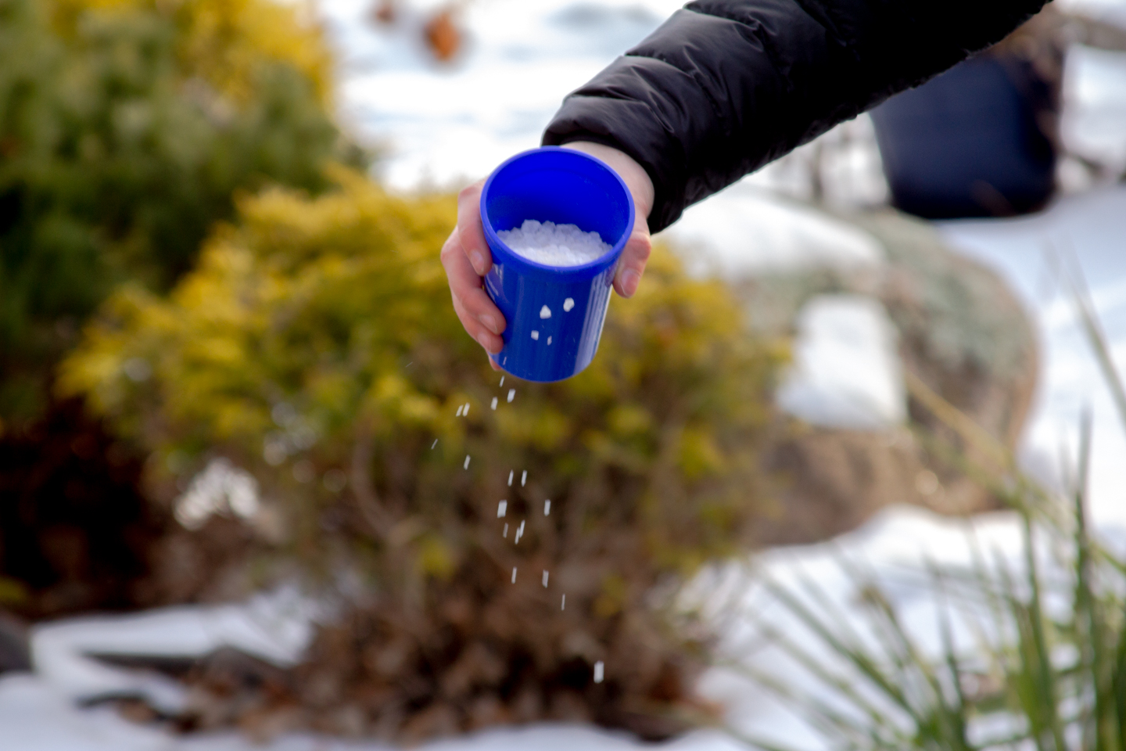

Post 2: Grass clippings
Facebook: Remember to keep grass clippings off the street and pavement when you mow your lawn! This protects water quality - and saves money. Sweep them back onto your lawn so they don't wash down the nearest storm drain and into your local lake or stream where they would become food for algae. Learn more: mn.adopt-a-drain.org
Twitter: Remember to keep grass clippings off the street and pavement when you mow your lawn! Sweep them back onto your lawn so they don't wash down the nearest storm drain and into your local lake or stream where they would become food for algae. Learn more: mn.adopt-a-drain.org
Instagram: Remember to keep grass clippings off the street and pavement when you mow your lawn! This protects water quality - and saves money. Sweep them back onto your lawn so they don't wash down the nearest storm drain and into your local lake or stream where they would become food for algae.
Image:
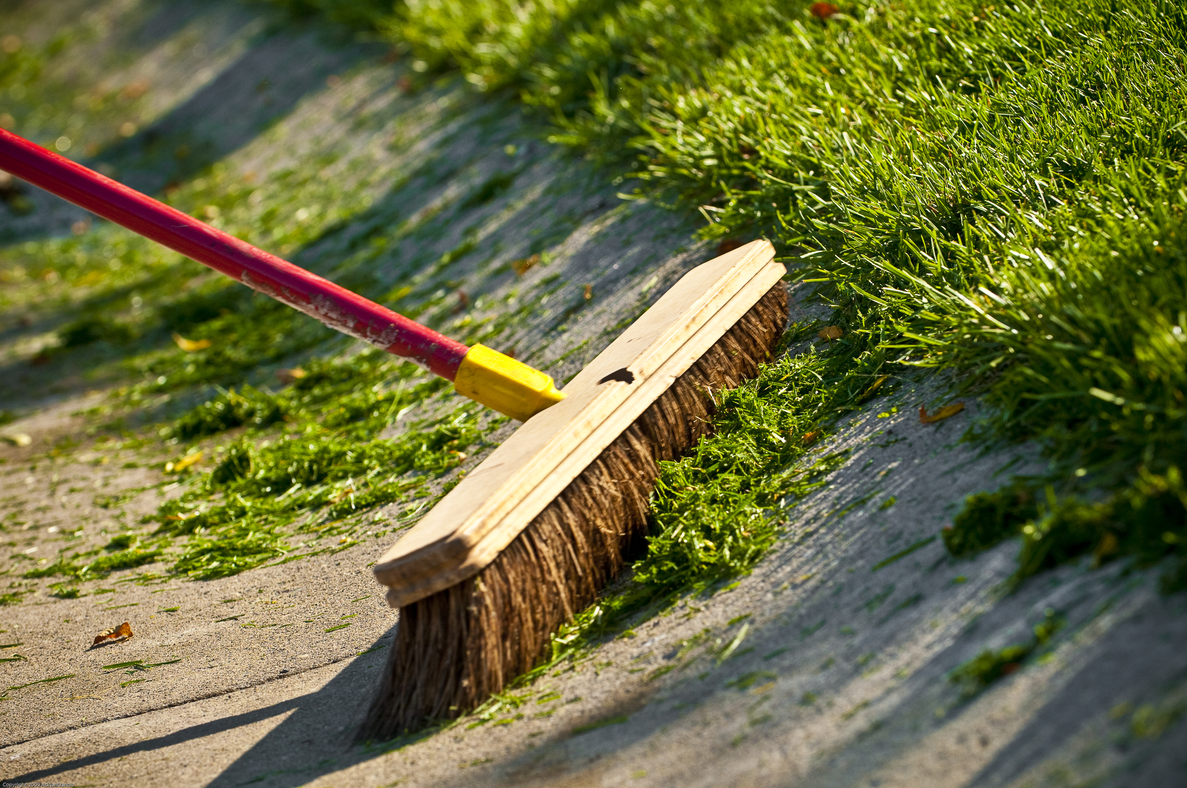

Post 3: Kick the chemicals
Facebook: Use lawn and garden chemicals wisely. They can harm pollinators and wash into the street’s storm drains that connect directly into nearby lakes and streams. Read and follow the label instructions, use the minimum amount needed to control the problem, consider using alternative or natural remedies to control weeds and pests, or remove the problem by hand. Remember, chemical treatments should be a last resort.
Twitter: Use lawn and garden chemicals wisely by following the label instructions and using the minimum amount needed. They can harm pollinators and wash into the street’s storm drains that connect directly into nearby lakes and streams. Remember, use chemicals only as a last resort.
Instagram: Use lawn and garden chemicals wisely. They can harm pollinators and wash into the street’s storm drains that connect directly into nearby lakes and streams. Read and follow the label instructions, use the minimum amount needed to control the problem, consider using alternative or natural remedies to control weeds and pests, or remove the problem by hand. Remember, chemical treatments should be a last resort.
Images:

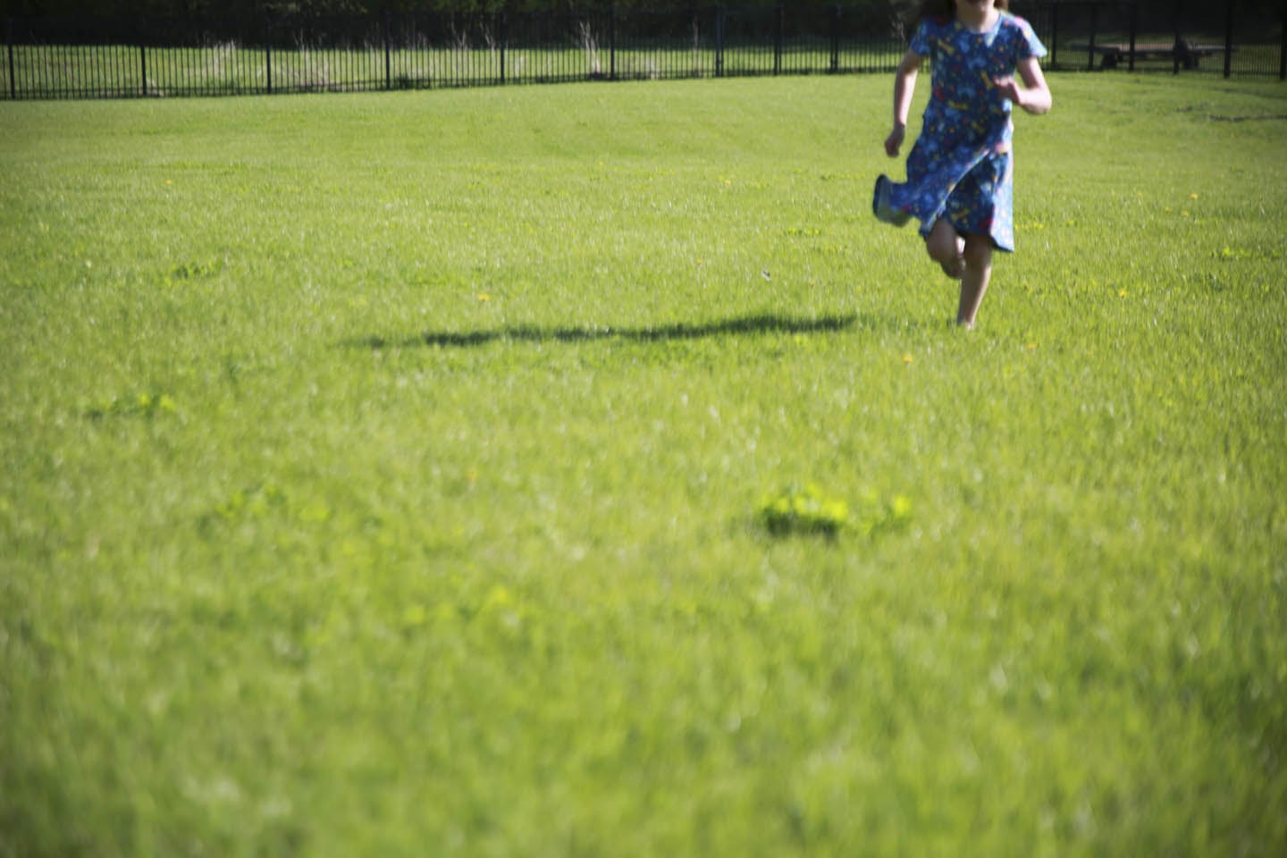

Post 4: Mow high
Facebook: Mow your grass to a height of three inches. Keeping your grass a little longer helps roots grow deeper into the soil, suppresses weeds, and requires less watering. If you do need to irrigate, do so in the morning and keep sprinklers on your lawn and plants, not on sidewalks or in the street.
Twitter: Mow your grass to a height of three inches. Keeping your grass longer helps roots grow deeper into the soil, suppresses weeds, and needs less water. If you do need to irrigate, do so in the morning and keep sprinklers on your lawn and plants, not on sidewalks or in the street.
Instagram: Mow your grass to a height of three inches. Keeping your grass a little longer helps roots grow deeper into the soil, suppresses weeds, and requires less watering. If you do need to irrigate, do so in the morning and keep sprinklers on your lawn and plants, not on sidewalks or in the street.
Image:
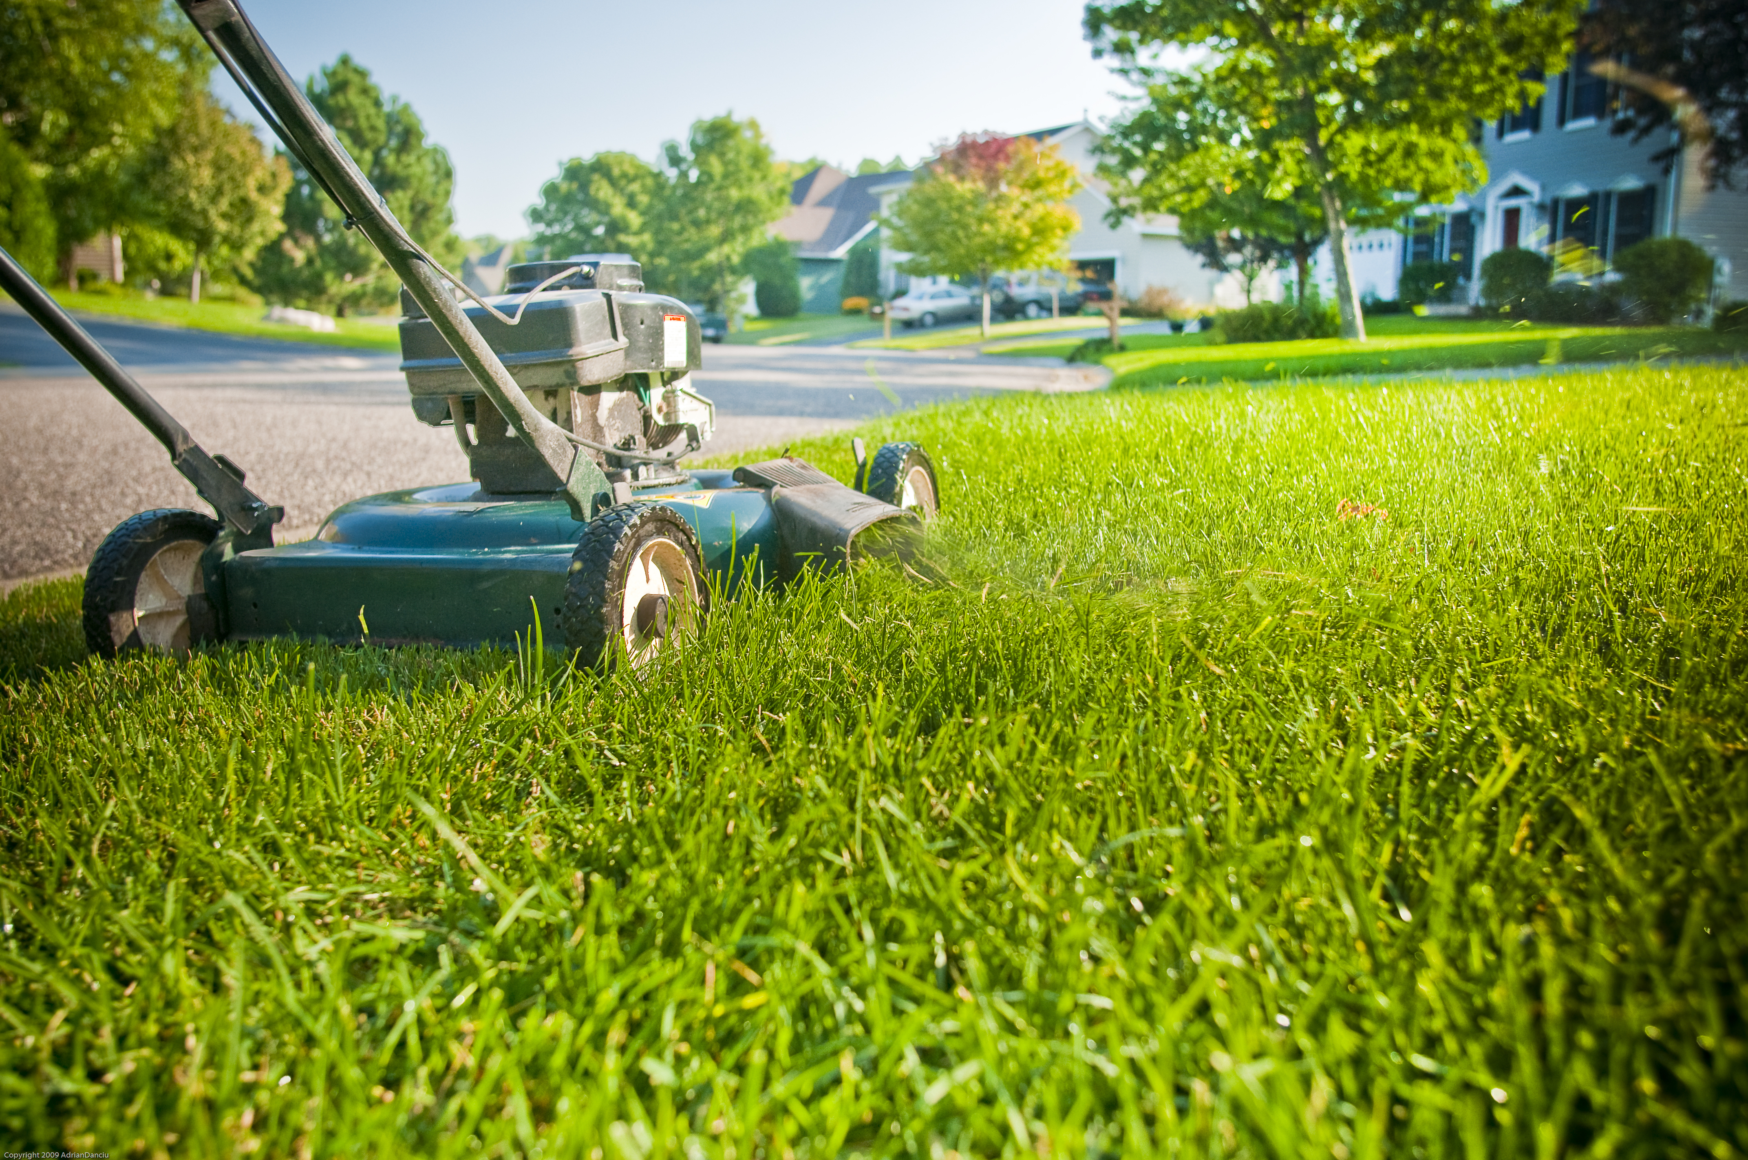

Post 5: Scoop the poop
Facebook: Remember to grab a bag when you grab the leash! Pick up after your pets to ensure pet waste doesn’t end up in local lakes and streams. Pet waste contains bacteria such as E. coli that, when left on the ground, can be washed into lakes and rivers when it rains. Pet waste also contains nutrients that cause destructive algae blooms in lakes and streams.
Twitter: Remember to grab a bag when you grab the leash! Pick up after your pets to ensure pet waste doesn’t end up in local lakes and streams. Pet waste contains bacteria such as E. coli that, when left on the ground, can be washed into lakes and rivers when it rains. #ScoopThePoop
Instagram: Remember to grab a bag when you grab the leash! Pick up after your pets to ensure pet waste doesn’t end up in local lakes and streams. Pet waste contains bacteria such as E. coli that, when left on the ground, can be washed into lakes and rivers when it rains. Pet waste also contains nutrients that cause destructive algae blooms in lakes and streams. #ScoopThePoop
Image:
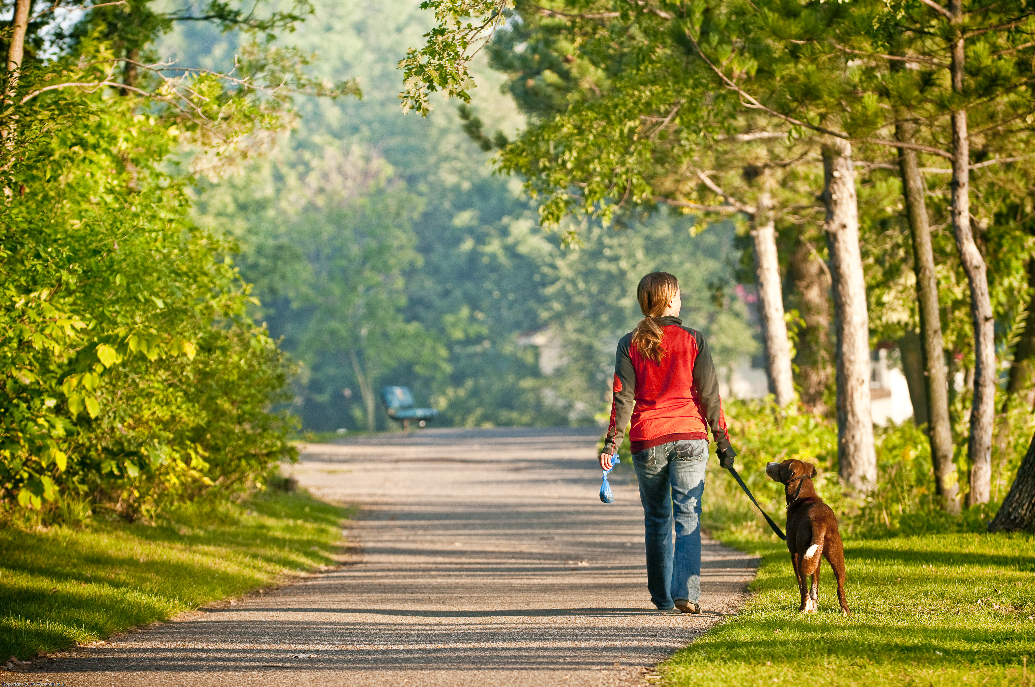

Post 6: Adopt a Drain
Facebook: Keep drains free of leaves, grass clippings, and litter. Water entering a storm drain is carried directly to the nearest water body carrying leaves, grass, soil, litter and anything else it picks up along the way. This clogs stormwater infrastructure, contributes to street flooding, harms wildlife, and pollutes our waters. Remember, nothing but rain down the drain! Learn more and get resources at mn.adopt-a-drain.org @AdoptADrainMN
Twitter: Keep drains free of leaves, grass clippings, and litter. Water entering a storm drain is carried directly to the nearest water body along with everything it picks up along the way. Remember, nothing but rain down the drain! mn.adopt-a-drain.org @AdoptADrainMN
Instagram: Keep drains free of leaves, grass clippings, and litter. Water entering a storm drain is carried directly to the nearest water body carrying leaves, grass, soil, litter and anything else it picks up along the way. This clogs stormwater infrastructure, contributes to street flooding, harms wildlife, and pollutes our waters. Remember, nothing but rain down the drain! @AdoptADrainMN
Image:
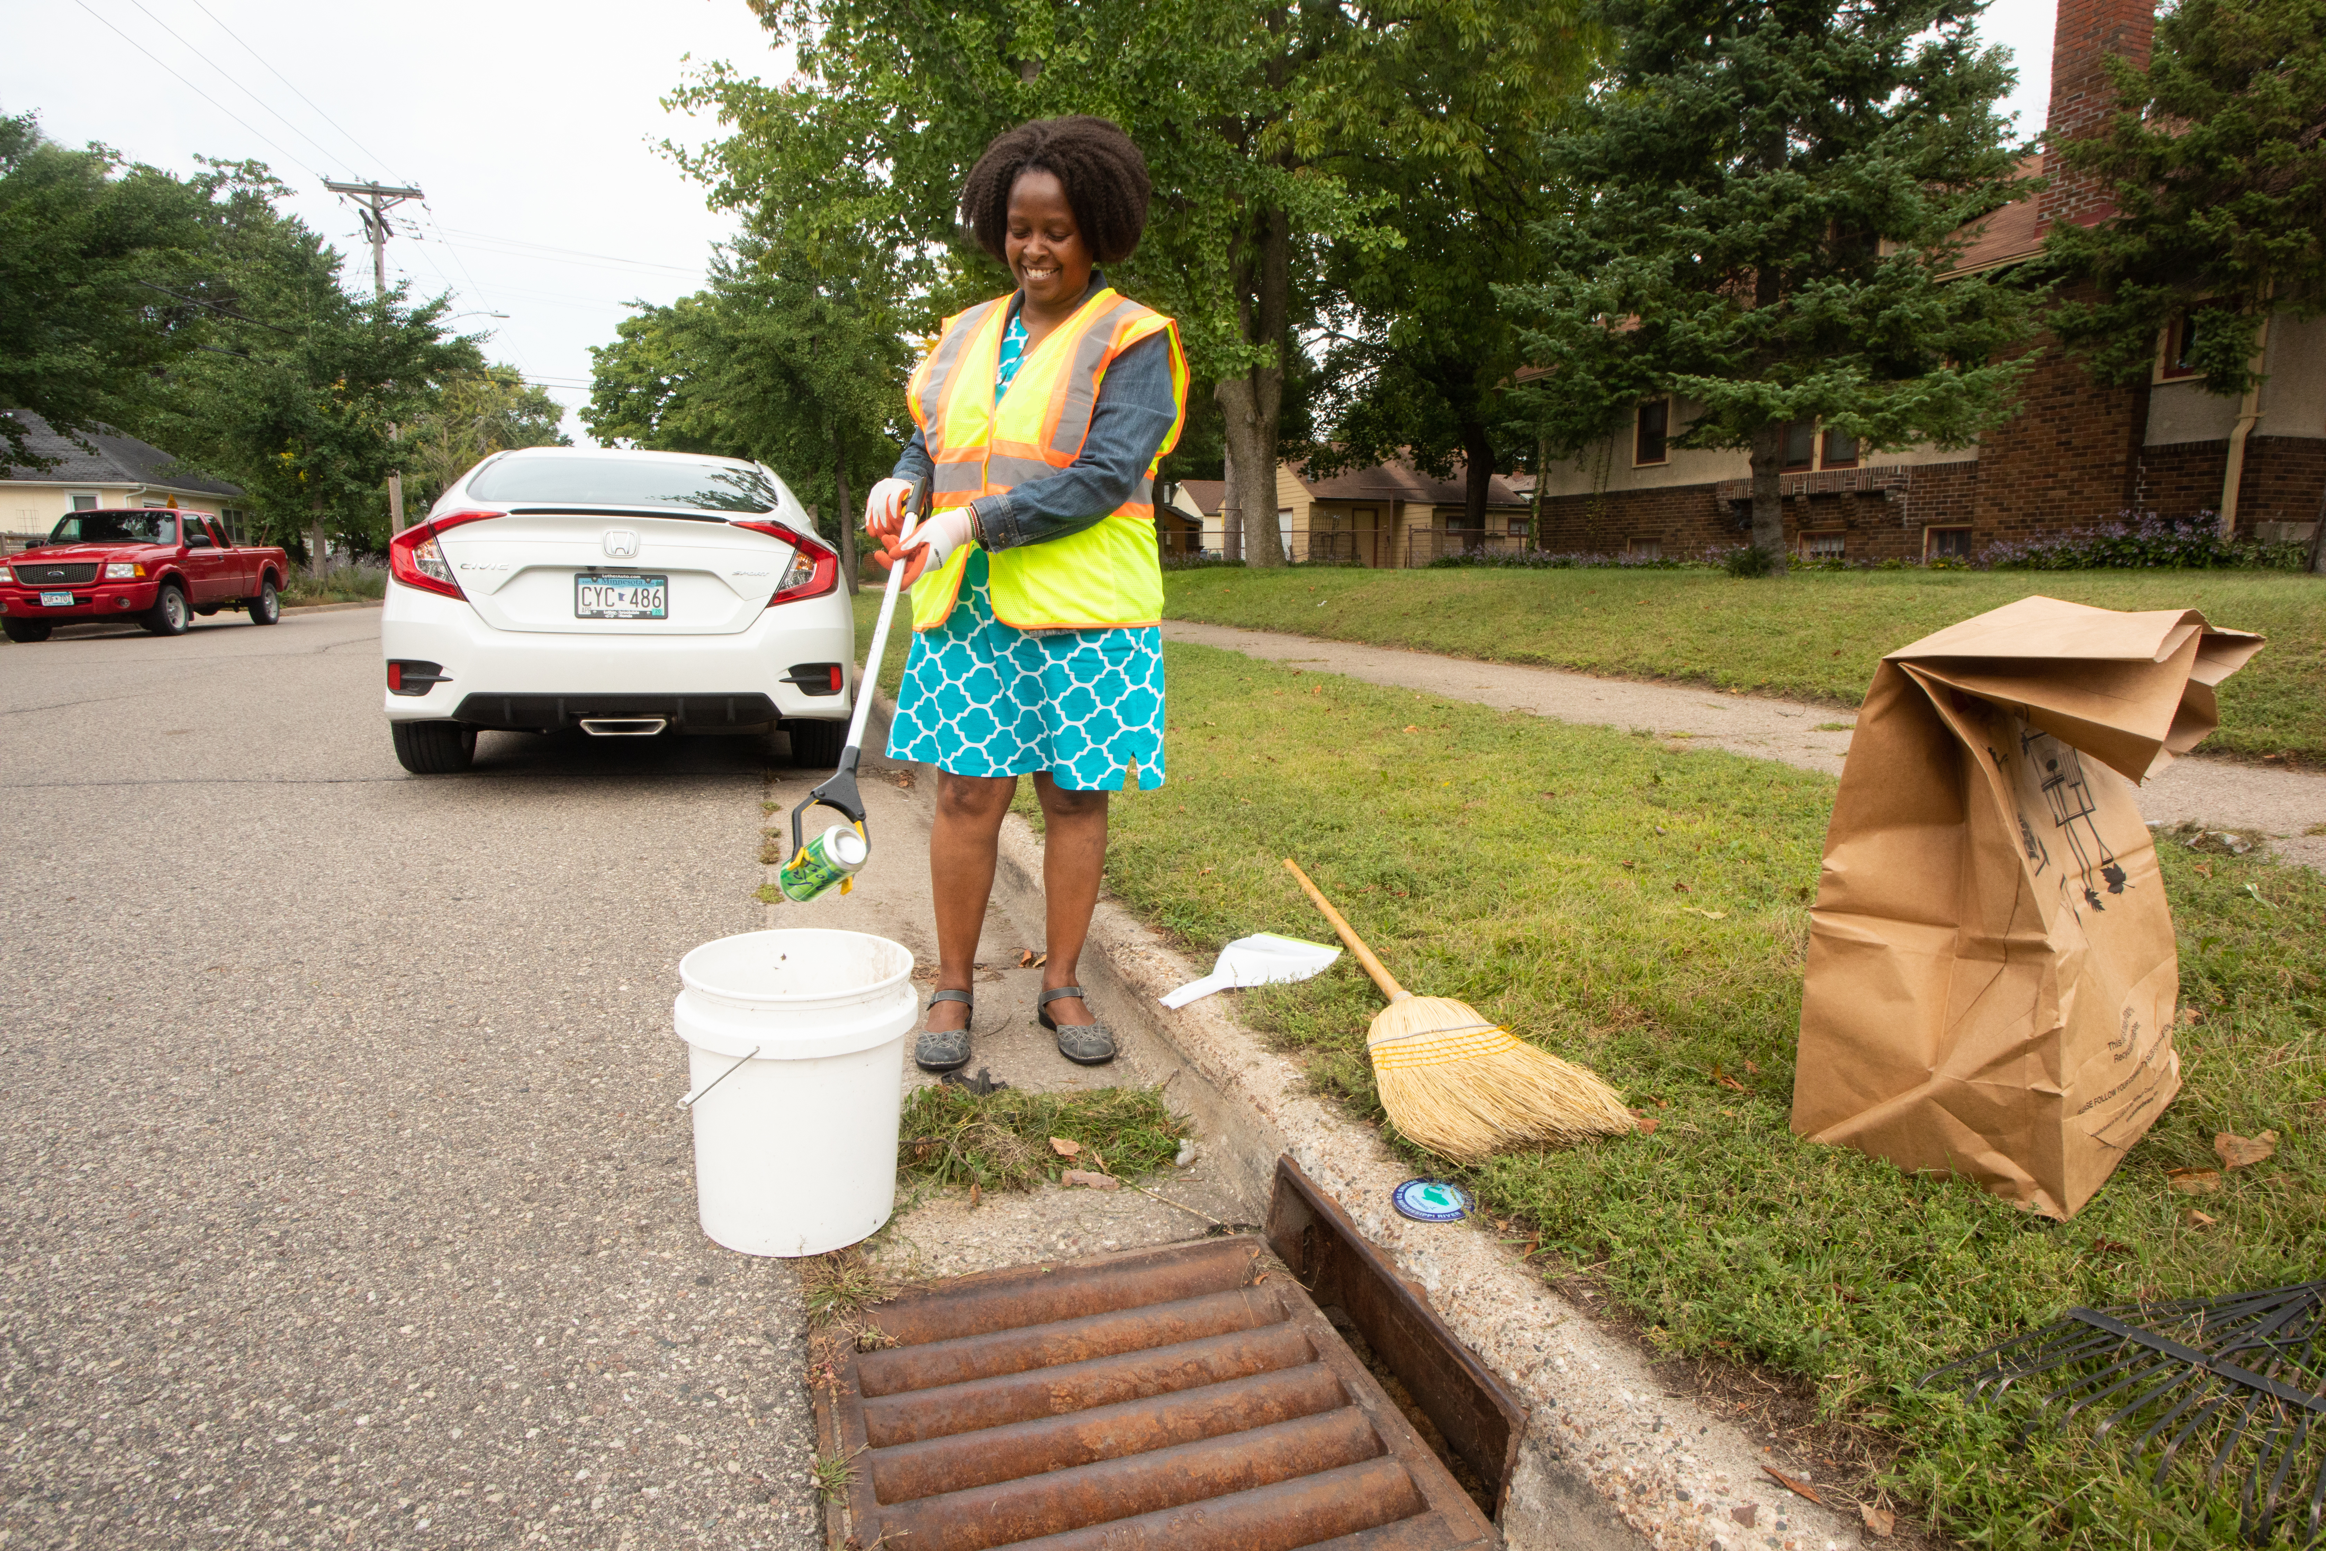

Post 7: Capture rainwater
Facebook: Direct your gutter downspouts onto your lawn or garden or into a rain barrel and use the collected rainwater for irrigation. You’ll save money on water and help prevent pollution carried to lakes and streams.
Twitter: Direct your gutter downspouts onto your lawn or garden or into a rain barrel and use the collected rainwater for irrigation. You’ll save money on water and help prevent pollution carried to lakes and streams. #HealthyLakes
Instagram: Direct your gutter downspouts onto your lawn or garden or into a rain barrel and use the collected rainwater for irrigation. You’ll save money on water and help prevent pollution carried to lakes and streams. #HealthyLakes
Image:
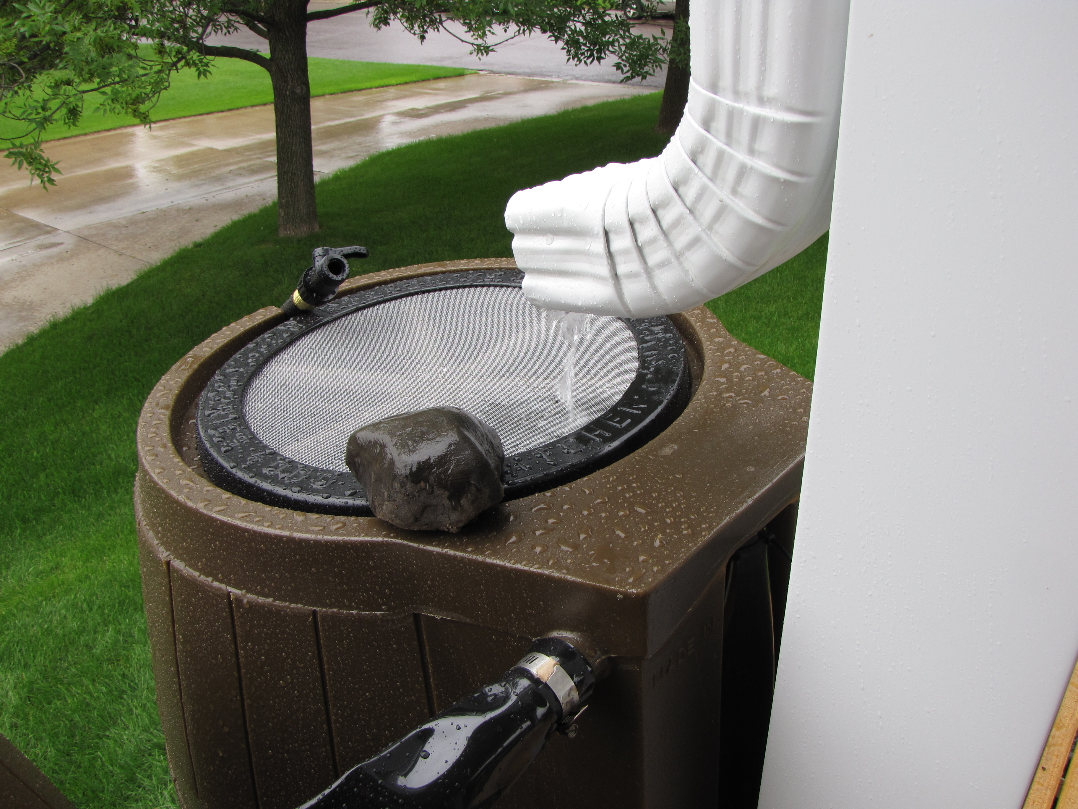

Post 8: Replace turf
Facebook: Trade some of your turf for native plants or choose a turfgrass alternative, which require less mowing and watering. Native plants provide pollinator habitat, are drought resistant, and their deep roots bring rain down into our ground water. Less mowing also improves air quality. Check local ordinances for maintenance requirements. @BlueThumbMN
Twitter: Trade some of your turf for native plants that provide pollinator habitat, are drought resistant, and their deep roots bring rain down into our ground water. Less mowing also improves air quality. #TurfAlternative #BeeLawn @BlueThumbMN
Instagram: Trade some of your turf for native plants or choose a turfgrass alternative, which require less mowing and watering. Native plants provide pollinator habitat, are drought resistant, and their deep roots bring rain down into our ground water. Less mowing also improves air quality. Check local ordinances for maintenance requirements. #TurfAlternative #BeeLawn @BlueThumbMN
Image:
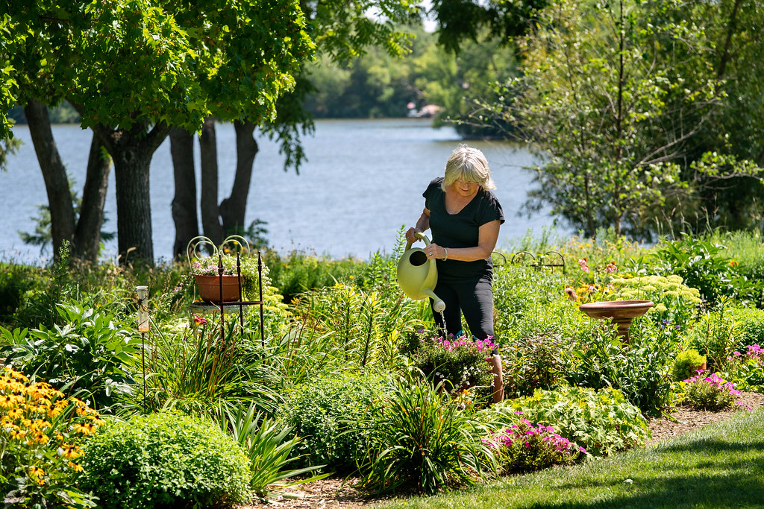

Post 9: Un-pave the way
Facebook: Choose pervious paving for walks, patios, and driveways. Paving stones and porous pavement let water soak into the ground, recharging groundwater and keeping runoff out of the street.
Twitter: Choose pervious paving for walks, patios, and driveways. Paving stones and porous pavement let water soak into the ground, recharging groundwater and keeping runoff out of the street. #WaterQuality #PerviousPavers
Instagram: Choose pervious paving for walks, patios, and driveways. Paving stones and porous pavement let water soak into the ground, recharging groundwater and keeping runoff out of the street. #WaterQuality #PerviousPavers
Image:
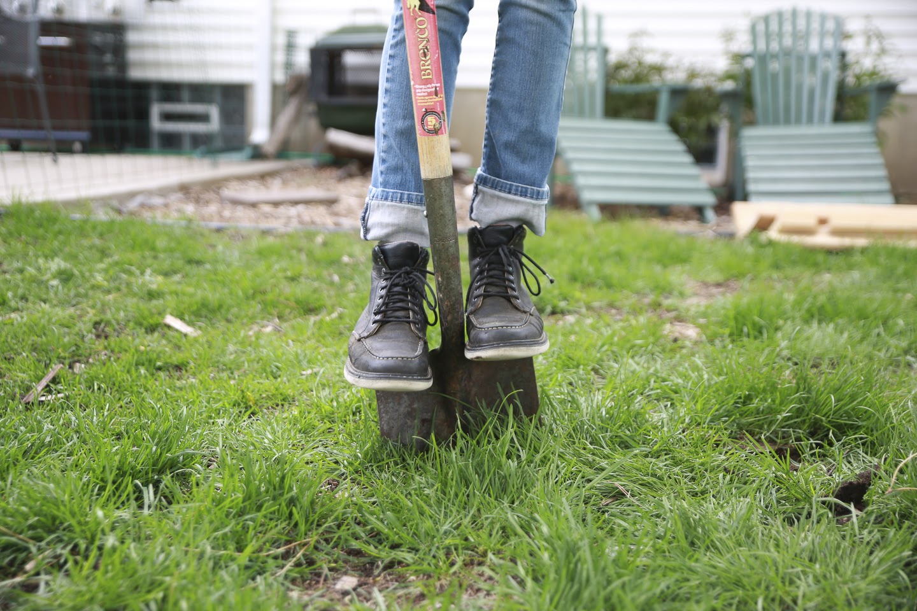

Post 10: Conserve water
Facebook: Reduce water use by watering your lawn only when it’s needed during dry periods. Your lawn only needs about one inch of water a week (including from rain). Water early in the morning to reduce evaporation. Conserve water by sweeping, rather than hosing off, driveways and sidewalks. Install WaterSense fixtures inside and outside and maintain them regularly.
Twitter: Reduce water use by watering your lawn only when it’s needed during dry periods. Your lawn only needs about one inch of water a week (including from rain). Water early in the morning to reduce evaporation. #WaterSmart
Instagram: Reduce water use by watering your lawn only when it’s needed during dry periods. Your lawn only needs about one inch of water a week (including from rain). Water early in the morning to reduce evaporation. Conserve water by sweeping, rather than hosing off, driveways and sidewalks. Install WaterSense fixtures inside and outside and maintain them regularly. #WaterSmart
Image:
