

Promotional materials for Hennepin County’s 2026 household hazardous waste collection events

About the events
In 2026, Hennepin County will hold household hazardous waste community collection events throughout the county—the schedule includes four total events.
Events will take place Friday and Saturday from 9 a.m. to 3 p.m. each day. Electronics are not accepted at these events; we will collect household hazardous waste only.
Download or order flyers of all 2026 collection events
Flyers for individual events are being created. Email environment@hennepin.us if you would like them sent to you once complete.

What residents should know
- Residents should remain in their vehicles unless otherwise directed by staff.
- Items should be stored in the trunk of the vehicle, bed of truck, or in a trailer. Only bring in items that one person can load in a vehicle by themselves. Staff will remove most items from vehicles.
- Our events welcome residents arriving via bicycles and walk-ups — bikers can use the drive through traffic system as if they were a car.
- Because of the hazardous nature of the products being collected at these events, be sure to pack your HHW items to prevent spills, leaks, and breakage.
- We ask residents attending by foot to stay out of the collection areas.
- Residents are encouraged to safely store their household hazardous waste until they can attend a collection event. Find safe storage tips from the Green Disposal Guide.
Access the most recent event information at: HennepinCounty.gov/collectionevents

Contact
Program contact: Ryan Gastecki, ryan.gastecki@hennepin.us
Communications contact: Angie Ziobro, angie.ziobro@hennepin.us

Event list
Events take place Friday and Saturday 9 a.m. to 3 p.m.
Minnetonka, May 1 and 2
Public Works Department
11522 Minnetonka Boulevard
Minnetonka, MN 55305
Map to Minnetonka Public Works Department

Minneapolis, July 10 and 11
Jenny Lind Elementary School
5025 Bryant Avenue North
(enter off Dupont Avenue)
Minneapolis, MN 55406
Map to Jenny Lind Elementary School

Minneapolis, August 7 and 8
Sullivan STEAM School
3100 East 28th Street
Minneapolis, MN 55406
Map to Sullivan STEAM School

Orono/Wayzata, October 2 and 3
Hennepin County Public Works Orono Shop
3880 Shoreline Drive
Orono, MN 55391
Map to Public Works Shop
Location note: Some navigation apps will list this address as Wayzata and some will list it as Orono. Both will bring you to the correct location.

Sample newsletter article

Household hazardous waste collection event
<insert horizontal graphic here>
Hennepin is hosting a community collection event for county residents to safely and properly dispose of unwanted garden and household hazardous wastes. The collection event will be from 9 a.m. to 3 p.m.
<paste event location, date information, and flyer link here (find the full list at the top of this document)>

Learn more
Visit the household hazardous waste collection event webpage to learn what items will be accepted at the event, review safety guidelines, and view all 2026 events.

Social media post
<use portrait-sized graphic in your post>

Facebook/Instagram/X
Hennepin is hosting a community collection event for county residents to safely and properly dispose of unwanted garden and household hazardous wastes. The collection event will be from 9 a.m. to 3 p.m. on <DATES OF EVENT> at <location of event>. Learn more: https://www.hennepincounty.gov/collectionevents

2026 images and graphics

Minnetonka
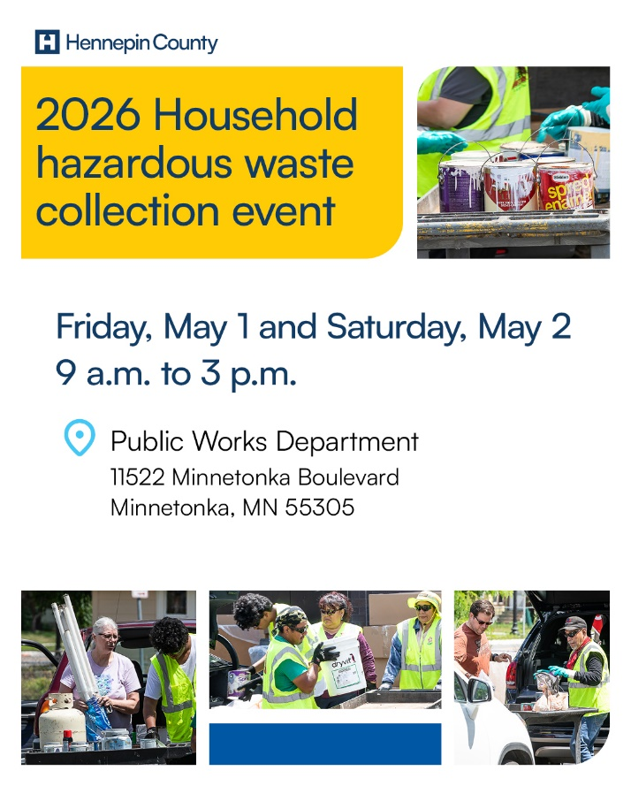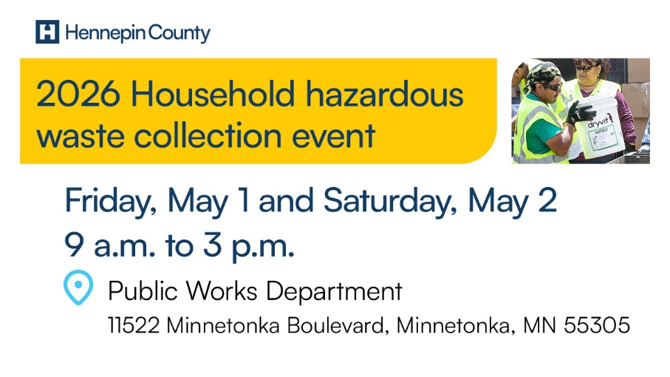

Minneapolis, Jenny Lind
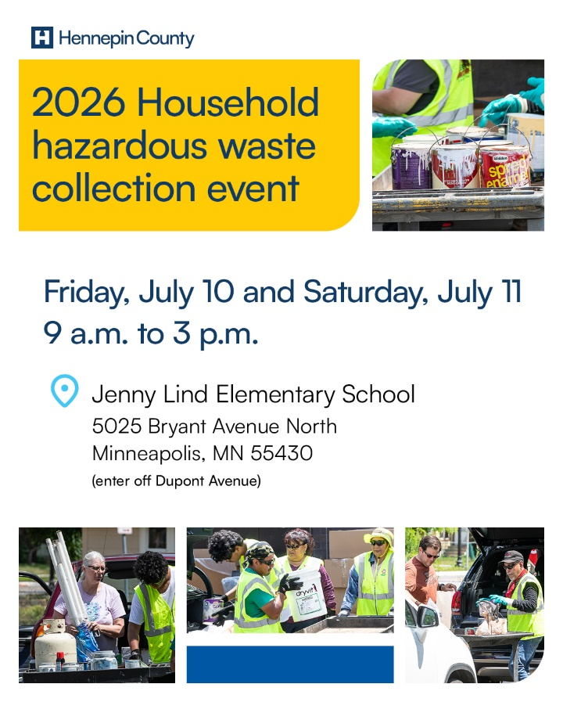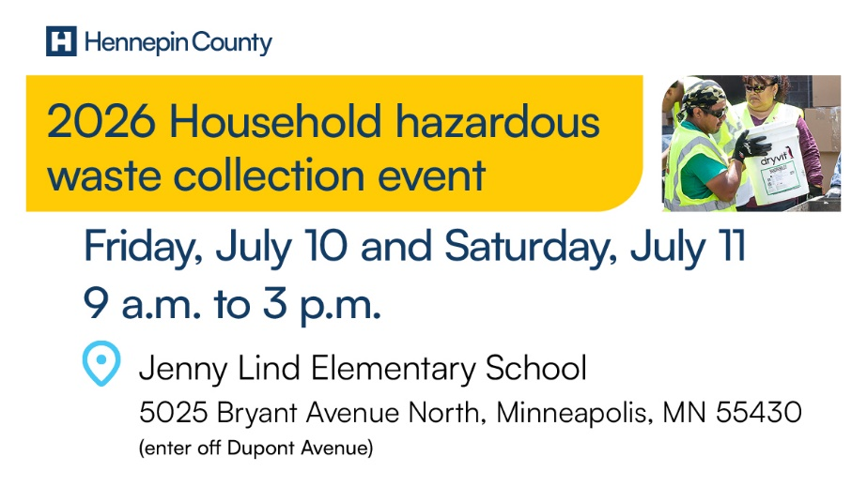

Minneapolis, Sullivan STEAM
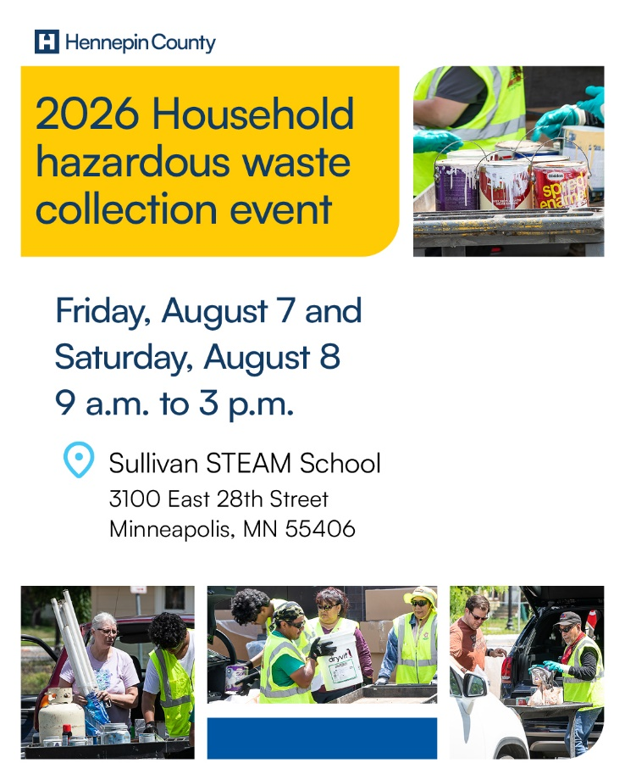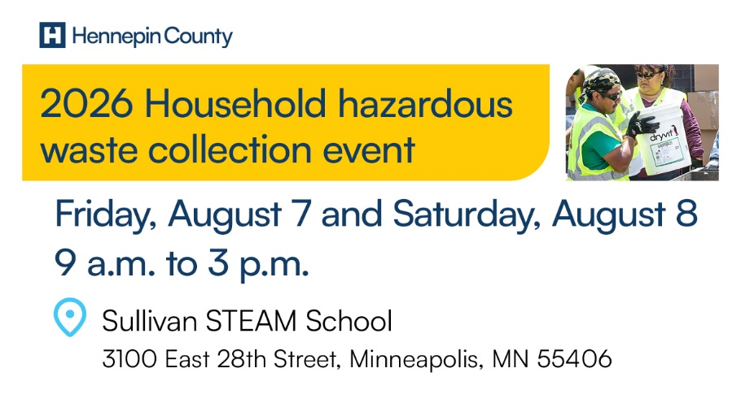

Orono
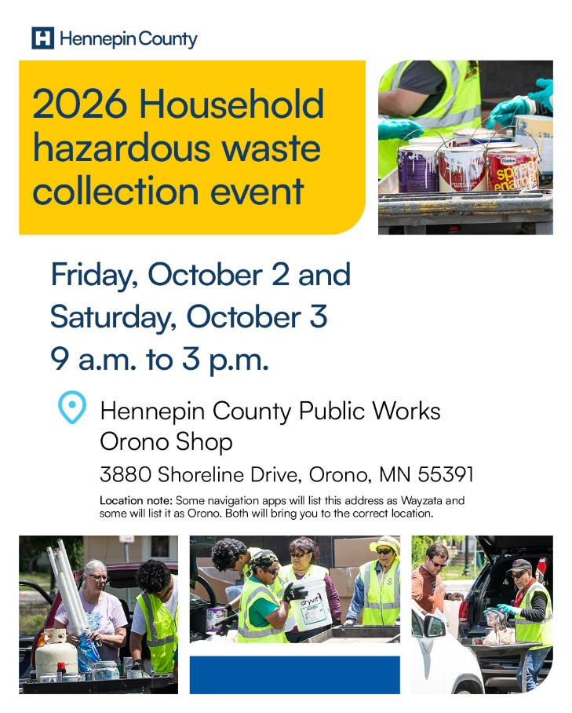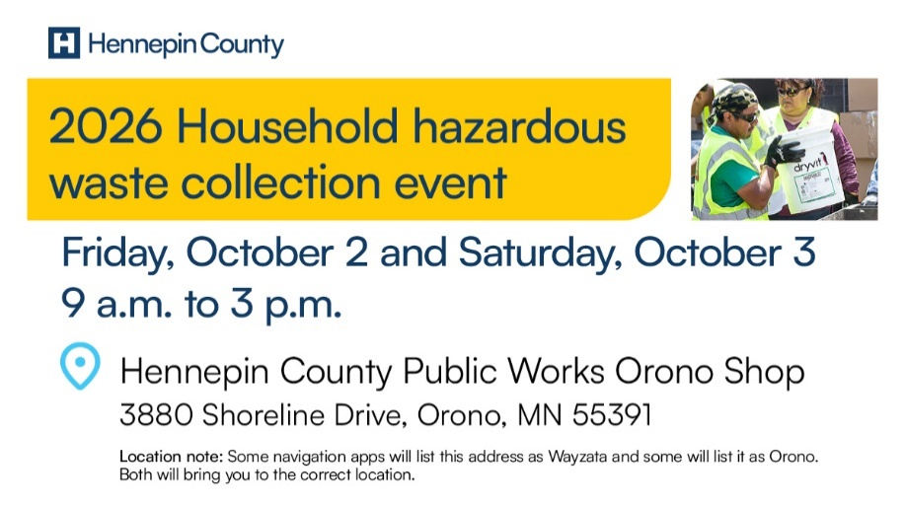

General images

