How to start organics recycling at work
  - 2019
Food scraps, wasted food, and compostable products including paper towels and napkins can all be recycled through organics recycling. Starting these programs demonstrates your organization’s commitment to the community, can help your bottom line, conserves natural resources, and reduces greenhouse gas emissions.
Hennepin County Environment and Energy
701 4th Avenue S, Suite 700, Minneapolis, MN 55415
612-543-9298 or businessrecycling@hennepin.us
hennepin.us/businessorganics

Contents
Assess 1
Develop an action plan 3
Educate 4
Prevent 5
Contact information 7

Assess
Track how full your dumpsters are when your hauler comes to empty them, and calculate how much you are recycling. If you share hauling services with other businesses consider using the “We share services chart” at the end of this document.
Assess current hauling
 | Volume | Quantity and container type | Number of pickups per week | Cost of service | Fullness at pickup
 | Cubic yards or gallons | # of dumpsters, carts, or a compactor | 1-7 per week or on call | Cost per month | Best estimate of how full containers get before pickup
Example | 30 cubic yards | 1 compactor | On call, avg 2x/month | $179 per pickup (Avg 2 per month) | 100% full
Example | 96 gallon | 3 carts | 5x per week | $200/month | Each is ½ full
Trash
Mixed recycling
Cardboard recycling
Organics recycling

Walk around your building and check the contents of your trash containers to determine which of the following materials are in there and how much.
Assess current waste generation
Area | What percentage of your trash is recyclable? | What percentage of your trash is organics? | How often are the trash and recycling bins next to each other?
Employee desks | Choose an item. | Choose an item. | Choose an item.
Employee break rooms | Choose an item. | Choose an item. | Choose an item.
Restrooms | Choose an item. | Choose an item. | Choose an item.
Kitchen (including prep area, serving line) | Choose an item. | Choose an item. | Choose an item.
Dining room | Choose an item. | Choose an item. | Choose an item.

Walk through your building and check to see what recyclable or compostable items are going in the trash. This will help you understand where you may need to add a container or which items are causing confusion and should be covered in a training or staff update.
Assess current sorting
 | Is this in your trash?
Compostable items: food waste, paper towels and napkins | Yes ☐ No ☐
Paper (e.g., office paper, mail, magazines, shredded paper, file folders, packing paper) | Yes ☐ No ☐
Paper boxes (e.g. cereal, cookie and cracker boxes, supplies and electronics boxes) | Yes ☐ No ☐
Plastic bottles, jugs, cups, food containers (clean) | Yes ☐ No ☐
Cardboard | Yes ☐ No ☐
Metal cans and pans (clean) from food and beverages | Yes ☐ No ☐
Cartons (milk and broth cartons, juice boxes) | Yes ☐ No ☐
Glass bottles and jars from food and beverages | Yes ☐ No ☐

Develop an action plan
Organics recycling for composting
Contact your hauler to inquire about adding recycling service. Consider calling additional haulers to compare prices. You may want to ask:
- What are the costs for different sized dumpsters?
- How much do I get charged each time my recycling dumpster is serviced?
- Can I get paid for separating cardboard?
- Can you help me right-size my dumpsters?
  - Right-sizing a dumpster is correcting the size of dumpster (and could include reducing frequency of hauling) to ensure that you don’t have waste overflowing from one or more dumpsters. The larger the dumpster picked up less frequently, the more you save.
Organics recycling for compost requires using compostable liners that are BPI certified. Many suppliers carry these bags.

Food-to-animals
Contract with a farmer to haul away food scraps and food that is no longer safe for people to eat. Food-to-animals organics recycling programs accept most food prep waste, plate waste, unpackaged spoiled or outdated food, and unpackaged frozen food. Note that some food-to-animals programs cannot accept meat or coffee grounds. These programs do not allow for compostable paper products like paper towels or certified compostable food service ware like plates, silverware, and cups.
Food scraps are cooked and processed to eliminate harmful bacteria. For collection ease, the farms provide businesses with lined plastic carts on wheels that are washed and re-lined after pick-up. Pick-up is offered up to six times a week.
- Barthold Recycling: St. Fancis, MN; 763-444-7447
- No Rest Ranch: Cambridge, MN; 763-689-4615
- Second Harvest Farms (North): Isanti, MN; 763-286-5557

Create a list of containers needed
Area of building | Number and type of containers needed | Placement | Notes
e.g., break room | 1 recycling, 1 organics | Next to sink, under counter | Downsize trash container

Set up your collection bins
Set your program up for success by making the right choice the default action for your staff, and making it obvious and easy.
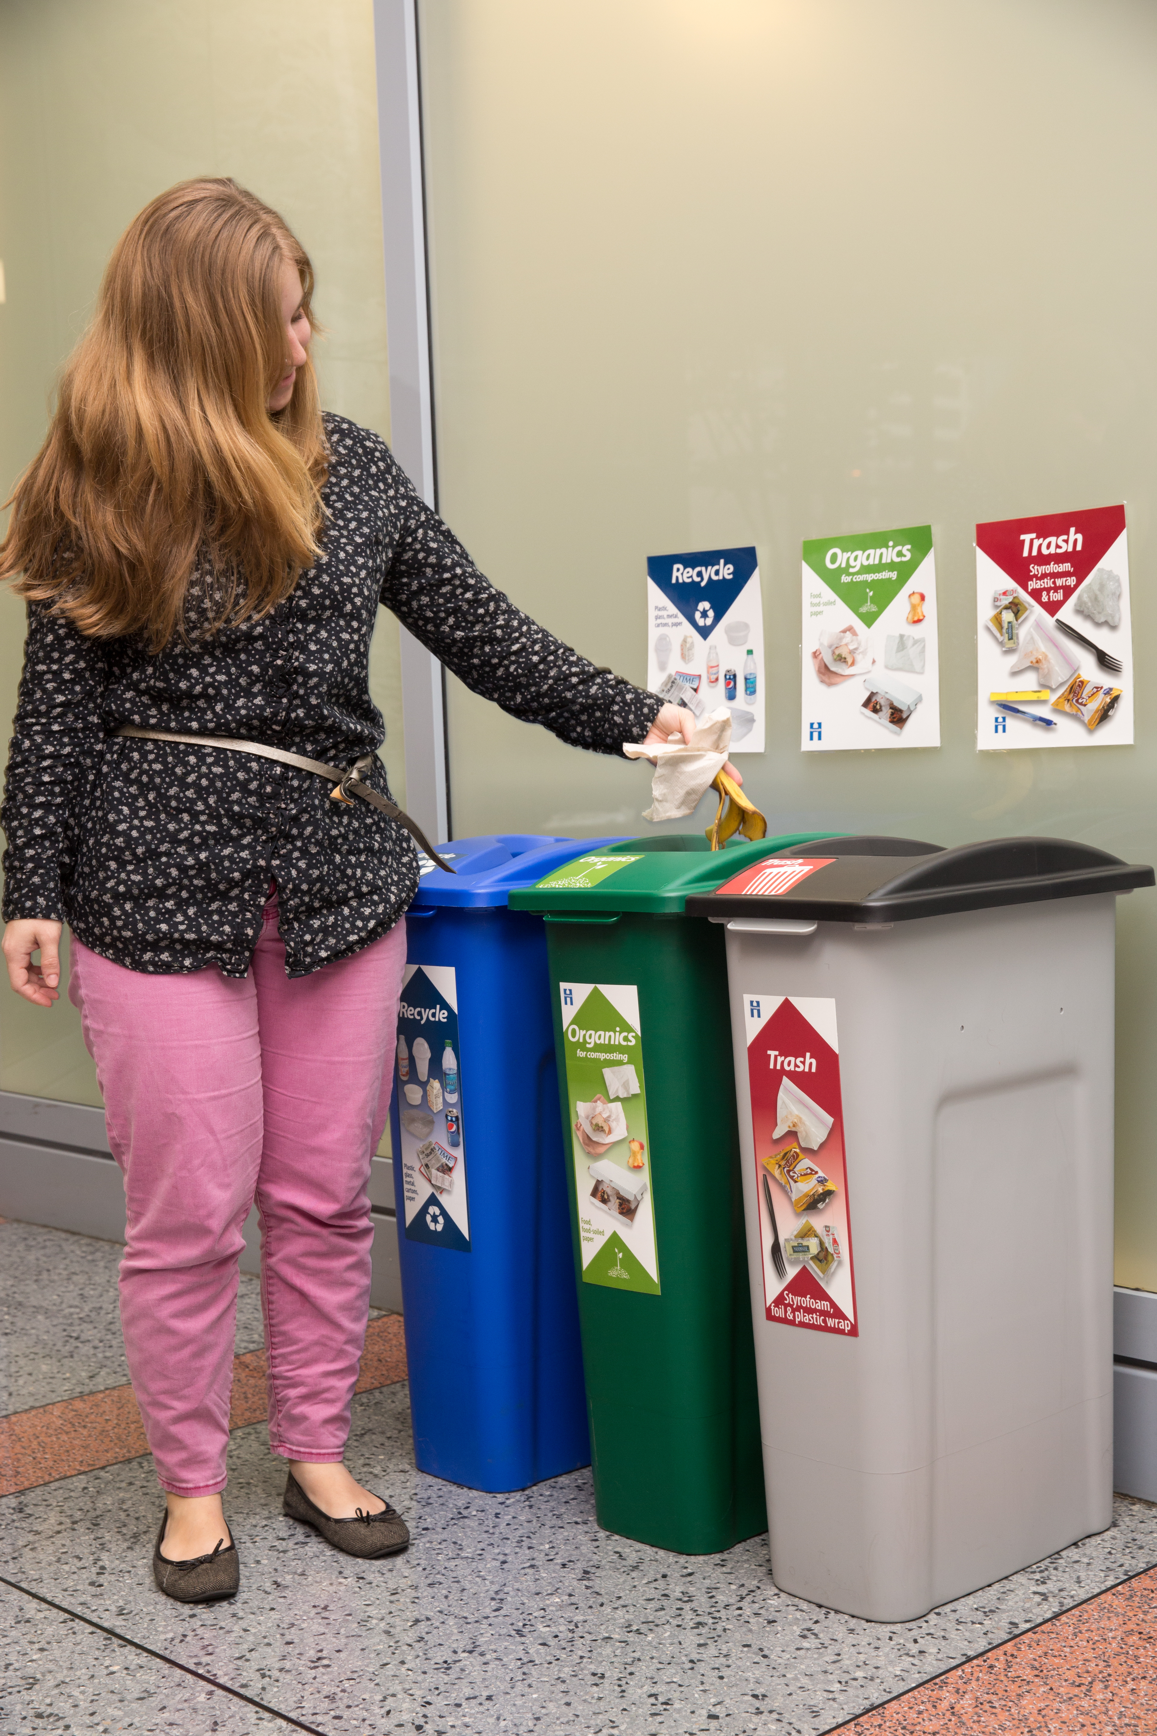
Color code
Use common colors for bins and labels. Color coding makes it easier to quickly identify what the bin is meant for, and is an important part of an effective recycling program. Make it as consistent as possible.
Locate
Place bins in places where waste is generated or where people often walk by. Centralizing waste bins saves time and money.
Pair
Place waste stream bins next to each other. They should be touching and lined up to reduce recyclables ending up in the trash.

Educate
Staff training
Train all staff who must properly sort or manage waste to make sure everyone knows how to properly sort waste into trash, recycling, and organics recycling. If you have cleaning staff they should be involved from the beginning, and are key players in the success of your waste management processes.
Create a team
Consider forming a green team or appointing a recycling champion who will keep everyone informed of the business’ progress toward reducing waste and recycling more.
Share goals
Share recycling goals and progress with your staff to gain support and keep attention on doing the right thing and not contaminating recycling and organics recycling.
Promote
Even if you do not have front-of-house organics recycling you can let customers know about your program! Waste reduction and recycling programs show customers and vendors that your business cares about the community and environment. Diverting waste into organic recycling reduces landfill use, recycles materials into usable products, and reduces greenhouse gases.

Track your training
Training needs to be recorded to comply with Ordinance 13. This includes tracking the person’s name, the organization they are employed by, the role they play managing the waste, and the date they received training.
All training should include:
- What a compostable liner is, where to find it, and to ensure that these are only used for organics recycling. Any waste collected in a plastic or normal trash liner must not be placed in the organics recycling collection container (cart, dumpster, or compactor)
- What is acceptable to put into the organics recycling and what items are not accepted.
[year] training for organics recycling for composting
Name | Organization | Organization’s role | Date of training | Signature

Prevent
Reducing waste is even better than recycling and organics recycling. Are there items in your trash or recycling that you could reduce, eliminate, or replace with reusable options? Reducing waste is a smart approach to saving money and natural resources.
Replace
Replace plastic cups, plates and utensils with reusable counterparts. Provide reusable dishes in break rooms and kitchens, and encourage employees to bring lunches in reusable containers
Audit
Audit your waste streams by doing a waste sort and identifying what is being thrown out. This will help you work with your staff to reduce those items.
Supply
Review your inventory regularly and track wasted food. This can be done by using software like LeanPath, which includes software and a scale for you to track your waste and help you fine-tune your menu to prevent waste.

Donate
Donate still edible food to people in need. Food donors are protected by the Bill Emerson Good Samaritan Food Act, which was passed into federal law in 1996. Organizations that donate food in good faith to a nonprofit for distribution to needy individuals are not subject to civil or criminal liability that arises from the condition of the food.
Identify foods you can donate
Review these food donation guidelines (PDF) to understand how to keep the food safe. Use a log sheet (DOCX) to track how donated food is handled.
Find an organization that will take your food
Call a hunger-relief organization and let them know what you have and the quantity. The recipient organization must have a food license. The following organizations are a good place to start:
- Sharing and Caring Hands, 525 N 7th St, Minneapolis, 612-338-4640
- Peace House Community, 1816 Portland Ave S, Minneapolis, 612-870-7263
- Community Bridge, 2400 Park Ave S, Minneapolis, 612-746-4108

Arrange for delivery of the food.
Talk to your staff about donating food. Some of the food establishments that donate food have found an employee who champions the effort and will volunteer to deliver the food. Hennepin County has trained volunteers who will come to your location and transport your food to a hunger-relief agency. To learn more, contact Nancy Lo at 612-348-9195.

We share waste services
Estimate the volume of trash your business generates by using the number of indoor containers your staff empties on a typical day. Fill in the table below to find out how much trash you generate.
Assess current waste
Size of container | Number of containers | Each container is emptied __ times per day | Weekly volume (yd³):

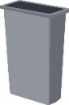

(23 gal)



(32 gal)

(44 gal)
Other:
(___ gal)
 |  |  | TOTAL weekly volume in cubic yards:

Contact information
Hennepin County Environment and Energy
701 4th Avenue S, Suite 700, Minneapolis, MN 55415
612-543-9298 or businessrecycling@hennepin.us
hennepin.us/businessorganics



